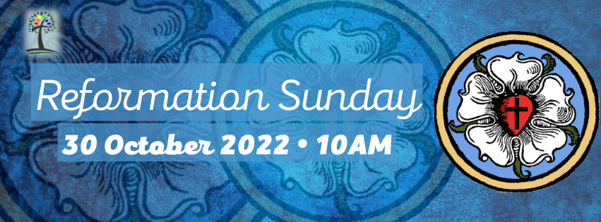
Prelude Eine Feste Burg ist Unser Gott Walther
Welcome
Announcements | Joys and Concerns | Silent Prayer
Hymn #275 “A Mighty Fortress Is Our God” Ein’ feste Burg
Verses 1, 2, 3
( The congregation may rise, in body or in spirit.)
Call to Worship
One: Be still!
All: We come to quiet ourselves in this haven of holiness.
Be still and know.
We come to discern the Word that can set us free.
Be still and know that God is:
our Hope, our Help, our Refuge, and our Redeemer: the living Word, ever bringing us into wholeness, harmony, justice, and joy.
Hymn #275 “A Mighty Fortress Is Our God” Ein’ feste Burg
Verse 4
Call to Reconciliation
We do not need to make grandstand plays to get God’s attention. God notices. We need only acknowledge our wandering off God’s way, as God makes good on the promises of grace and mercy. Join me as we pray together:
Unison Prayer of Confession
Dear Heart of the covenant of grace:
we have known your hopes for us, and disappointed them;
we have heard your words of faithfulness, and forgotten them;
we have seen your dreams for us and left them behind, tossed them aside, as though we knew better what fullness of life requires.
Forgive us, Hope’s Heart.
Silence every blustering word, so we may hear your mercy;
still every feeble attempt to justify ourselves, so we may be made right with you;
melt every frozen heart, so we might be drenched in your river of joy.
May Love’s Own Self continue to live in us, so we might be free to live forever with you.
(Silence is kept)
Assurance of Pardon
Be still and know the good news: God has not forsaken nor forgotten us, but redeems us. We are forgiven!
Why should we be afraid? God is in our midst — forgiving, restoring, sending. Thanks be to God! Amen.
Responsive Psalter: Psalm 46
One: God is our refuge and strength,
Many: An ever-present help in time of trouble.
Therefore we will not fear, though the earth should crumble,
Though the mountains shake in the heart of the sea;
Though its waters roar and foam,
And the mountains tremble with the surging.
There are streams from the river of life that bring joy to the city of God,
the holy habitation of justice and peace.
God is present in the midst of that city;
It will not fall;
God will help it when the morning dawns.
The nations are in an uproar,
Governments totter;
The voice of The Holy One issues forth,
Earth yields.
The Almighty is with us;
The God Who keeps covenant is our security.
Come, see what God does.
Does the Eternal One cause devastation on the earth?
No! God makes wars cease to the end of the earth;
Breaking the bow, and shattering the spear;
Burning the shields with fire.
“Throw down your weapons and know that I am God!
“I reign most high among the nations,
“I am sovereign in the earth.”
The Almighty is with us;
The God Who keeps covenant is our security.
A Thought for Young Minds
The Lord’s Prayer (debts/debtors) Hymnal, p. 35
Hymn #237 “Christ Jesus Lay in Death’s Bands” Christ lag in Todesbanden
All attending Church School may leave as we sing the hymn.
Offertory
A Stewardship Testimony Barbara Wiggins
One: God has poured gifts into our lives; we now return our tithes and offerings.
All: Let us gather our gifts with grateful praise,
and offer them to God’s purposes.
Receiving Our Offerings
Our church welcomes every size gift, and thanks you for your generosity.
Musical Offering Blessed Is the Man Jane Marshall
Doxology Old 100th
Praise God from whom all blessings flow;
praise Christ, all people here below;
praise Holy Spirit ever more;
One God of grace, whom we adore! Amen.
Unison Prayer of Dedication
God our Creator, you have blessed your world
with riches beyond counting.
Stretch our imaginations so that we live
in the confidence of your abundance:
ample for everyone, everywhere.
Bless each offering that we have gathered,
and bless the mission and ministries to which they are given.
Thy kin-dom come! Thy will be done! In Jesus’ name: Amen.
Scripture Reading Jeremiah 31:31-34 Testament, p. 899
Romans 3:19-28 New Testament, p. 187
Sermon “Unlocked” Pastor John A. Nelson
Pastoral Prayer
Hymn #309 “Come, Great God of All the Ages” Abbot’s Leigh
Benediction and Sung Amen
Postlude Toccata from Suite Gothique Léon Boëllmann

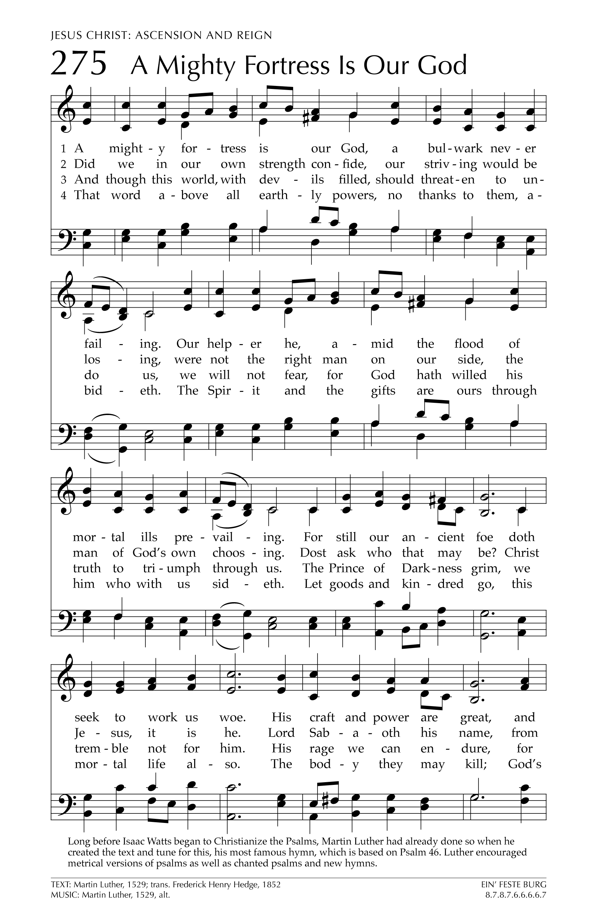
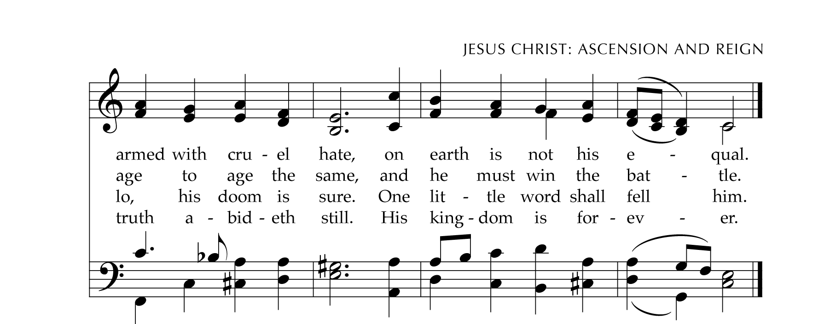
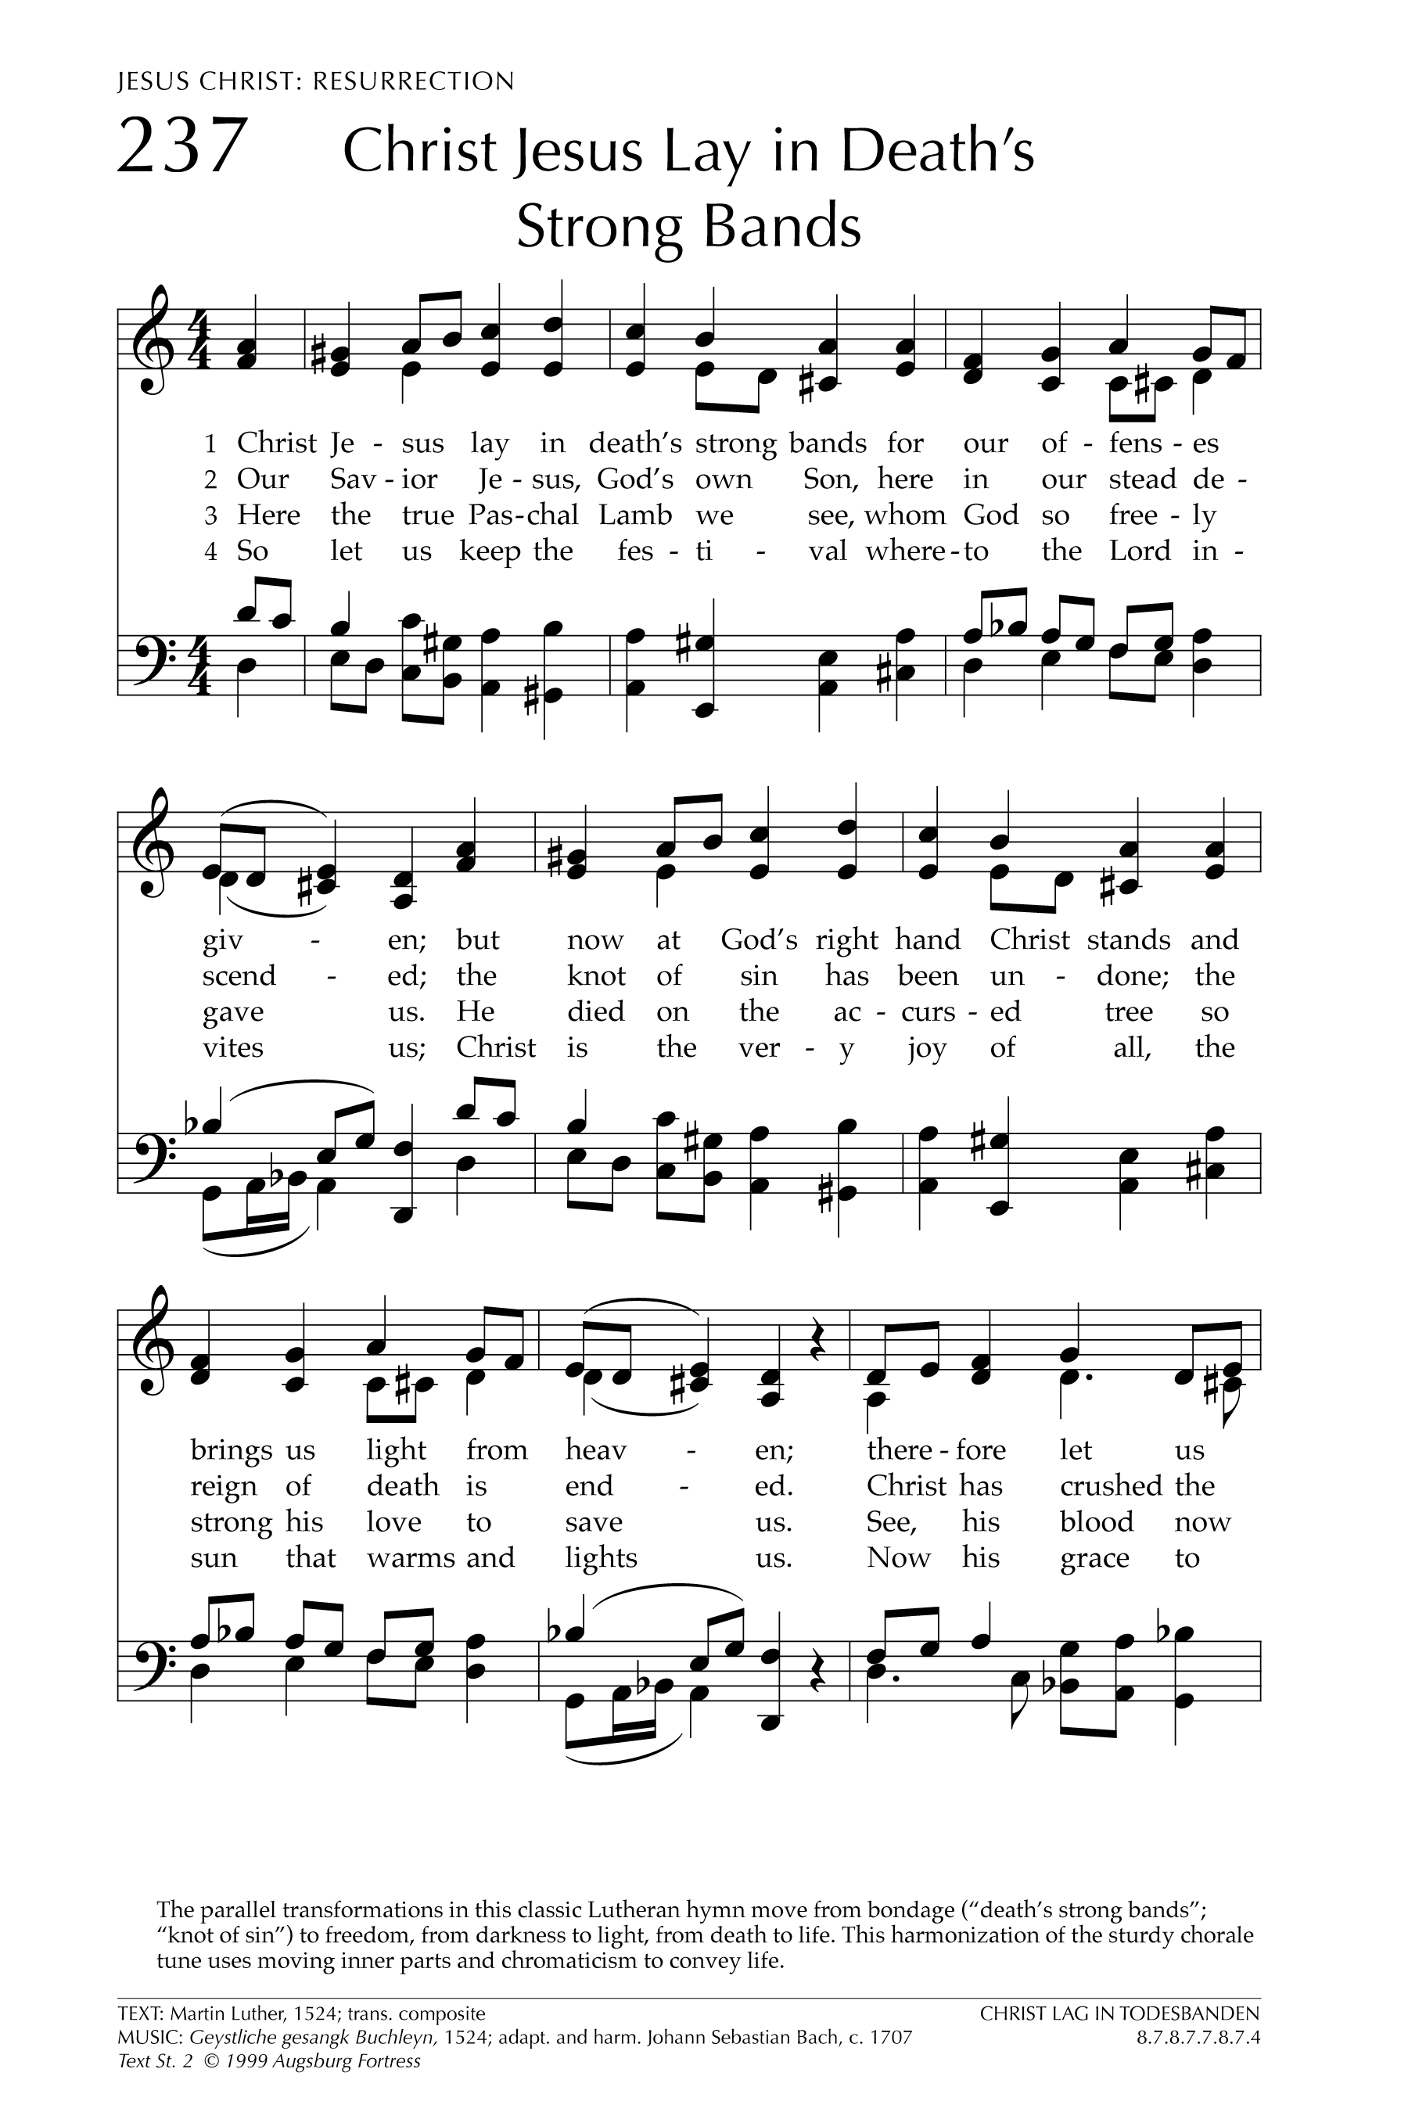

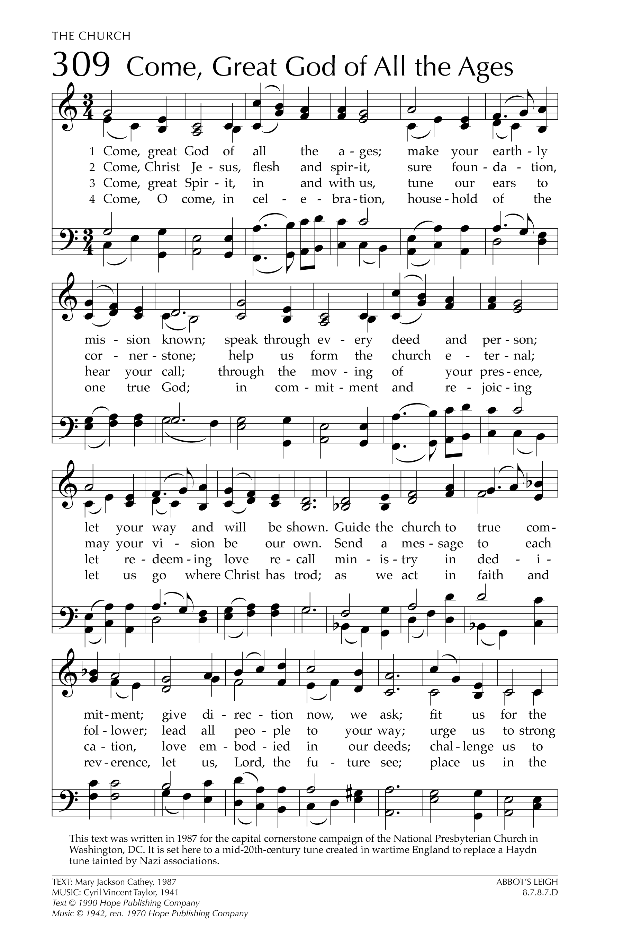
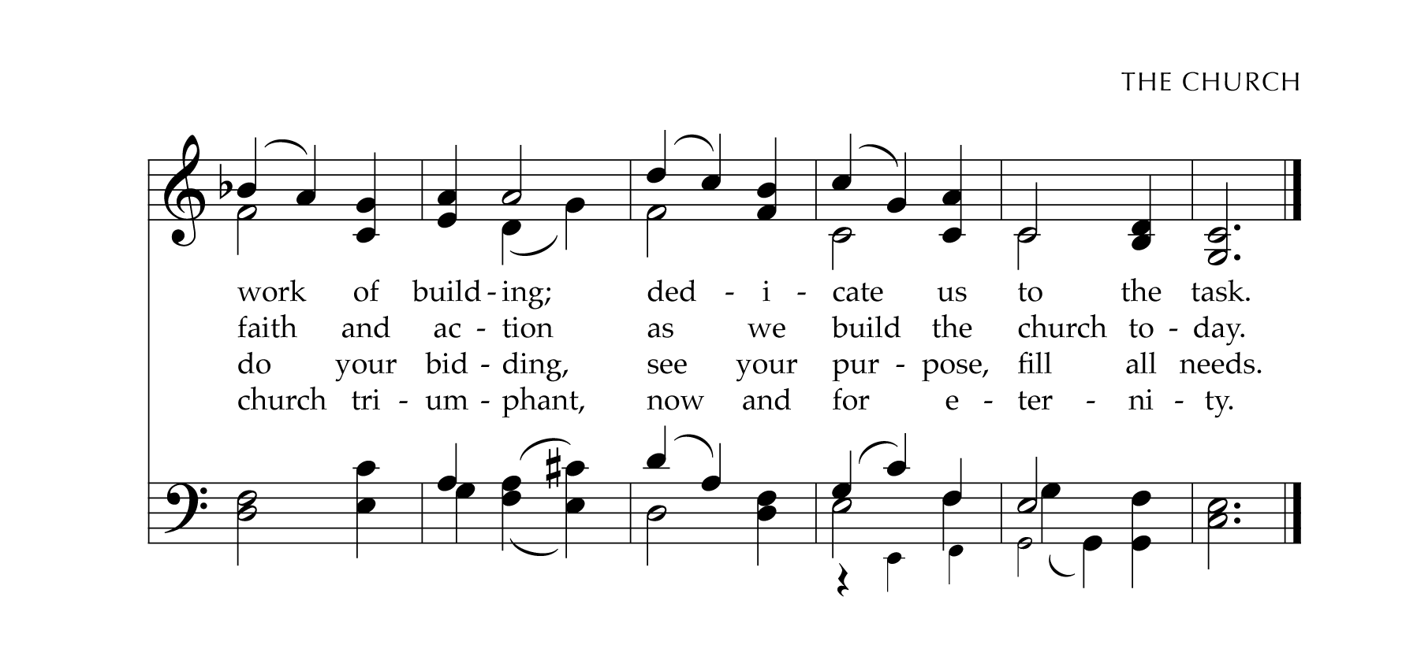

Welcome to Church!
Gathered in 1744, the Congregational Church of Salisbury is an Open and Affirming member of the United Church of Christ. It is also a welcoming home to people from a great variety of church backgrounds and life experiences. Your presence is a gift to us! We hope you will feel God’s Spirit here today through our worship and fellowship.
We seek to love God with all our hearts, souls, and minds and love our neighbors as ourselves. This Church is Open to all for participation, membership, leadership and employment regardless of race, ancestry, class, gender identity, physical and mental ability or sexual orientation. We Affirm each individual as a child of God, celebrating the total identity of each person.
As an Open and Affirming Congregation, we commit to work toward ending ignorance, fear, hatred, prejudice, and discrimination against any person.
Whoever you are, wherever you are on life’s journey,
you are welcome here!
If you are visiting us, Welcome! Please sign our guest book and introduce yourself to our Pastor or to one of the Deacons. Fill out a welcome card in the pew to join our email list. Assistive Listening Devices are available; please ask an usher for assistance.

Kindly set phones to silent (unless you’re expecting a call from Jesus).

Today’s Worship Leaders
Ushers: Sharon Tingley and Joanne Taber
Reader: Theresa Carroll • Deacon: Patricia Palmer
Flowers have been placed in the Meeting House by Anne Williams,
in honor of Easton Shedd.
Today’s liturgy is adapted and reprinted from Lectionary Liturgies by the Rev. Thom Shuman © 2022 (lectionaryliturgies.blogspot.com); used by permission.
Psalm adapted from The Psalms in Worship, Mary Susan Gast, © 2002; used by permission.

Our Ministry Team
Ministers: All Participants in the Life of the Congregation

Worship & Music
Music Director: David Baranowski
Bell Choir Director: Mary Davidson
Cantor: Jennifer Oberto

Faith Formation
Sunday School Coordinator:
Holly Tierney
Sunday School Assistant:
Jennifer Kronholm-Clark

Holding the Parts Together

Administrative Assistant: Loriann Chevremont
Bookkeeper: Alex Bercy
Sexton: Richard Tietjen
Church Officers: Betsy Beck, moderator; Jennifer Weigel, treasurer;
Jennifer Oberto, clerk
Pastor and Teacher: The Rev. Dr. John A. Nelson

Occasions for Service, Witness, and Prayer

In Our Prayers:
We gladly list joys and concerns, and typically print them for four weeks
after they are offered in worship. (Prayer requests may be renewed at any time.)

New additions:
Weekly prayer from UCC Global Ministries: for Global Ministries Mission Co-worker Ricardo Mayol, serving with the Ecumenical Christian Council of Guatemala • Guatemalan Cultural Action • National Coordination of Widows of Guatemala.
Nan McLune, in rehab.

Continuing concerns:
Lee Collins, recovering from foot surgery • the community of Bristol, CT, grieving the deaths of Sgt. Dustin DeMonte and Officer Alex Hamzy • Margaret Haubrich, in memory care • Baby Sid, grandson of Susie Belcher, born with esophageal atresia, for all giving him care, and for his family • The people of Ukraine and all striving to end war • All those serving or living in war or conflict zones around the world.
For those in treatment for cancer — John Lomanto, Jenny, Frank Swaye, David Douyea, MingMing, Deborah Merwin, Keith Blanton and others — prayers for healing and strength.

Family & Friends
who have passed away
Families and friends of more than 40,546 beloveds who have died due to Covid-19 disease in the last four weeks, including 10,846 in the US.
We thank God for the gift of life, and pray for the Spirit’s strong presence with family and friends who grieve.

Thanksgivings
Mariella Stuto, grand-niece of Loriann Chevremont, born October 24th • Asa Duncan Offensend, grandson of Janet and David, born October 12th

If you would like a pastoral visit, please call the church office (860-435-2442) or email Pastor John (jnelson@salisburyucc.org). Sometimes we don’t find out about an injury or illness or other need until long after — so please call!

This Week at Salisbury UCC

Sunday, 30 October
9:45am Online fellowship (via Zoom)
10am Worship
11am 278th Annual Meeting, Part I
Monday, 31 October
11:30am Duplicate Bridge Club
Tuesday, 1 November
4pm Centering Prayer (via Zoom)
5:15pm Hand Bell Choir
Wednesday, 2 November
12:30pm Staff Meeting
4pm Women’s Bible Study

Thursday, 3 November
7pm Choir Rehearsal
Friday, 4 November
8:45am Men’s Bible Study
Noon Meeting House Music & Meditation

Opportunities

Crescendo presents:

Music Across Borders
Baroque and Contemporary
Eastern European Choral Works
Today (Oct 30), 4pm
St. James Place, Great Barrington, MA
Visit crescendomusic.org for more information.

Board of Christian Action Thanksgiving Coat Drive
We are collecting new or gently-used warm outerwear for children and adults
during the next two weeks.
Please drop off your donations at the Parish Hall,
Monday – Friday, 8:30am–1:30pm, October 31st through November 14th
The coats will be delivered to FISH (Friends In Service to Humanity) on November 16th, and given to neighbors in need on the Saturday before Thanksgiving.
Last year our congregation was wonderfully responsive and helpful: let’s continue our tradition of generous care!

Please Recycle this Bulletin!
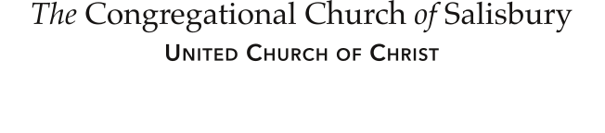
Whoever you are, wherever you are on life’s journey: you are welcome here.
30 Main Street | P.O. Box 392 | Salisbury, CT 06068 • 860-435-2442
email: welcome@salisburyucc.org • web: salisburyucc.org
Office Hours: 8:30am – 1:30pm, Monday-Friday

