The Congregational
Church of Salisbury
United Church of Christ

Whoever you are; wherever you are on life’s journey: you are welcome here.

8 September 2019 • 10:00am
Thirteenth Sunday • Season of Creation | Ocean Sunday
We worship today with the oceans of Earth, created by the Wisdom of God. We join the Psalmists and call the sea to roar with songs of praise. With the Christ of all Creation, we groan with the oceans and living things that rely on the waters that suffer from human acts of pollution.
Chiming of the Hour
Welcome
Prelude “Toccata in D Minor” J.S. Bach
Announcements | Joys and Concerns | Silent Prayer
Gathering
One: In the name of the Spirit of God who hovered over the primal waters,
in the name of the Word of God, which parted the waters for Earth to appear,
in the name of the Wisdom of God, who filled the deep with amazing designs, Amen!
Many: Holy! Holy! Holy! The oceans are filled with God’s presence.
Christ, we come into your presence, today, to worship in this sanctuary called Earth,
Holy! Holy! Holy!
Earth is filled with your presence.
Introit #768 “Somos el cuerpo de Cristo”
Call to Worship
One: We invite the oceans to worship with us.
Many: The deep sea currents and ocean reefs,
the mountain peaks on the ocean floor.
We call the seven seas to celebrate with us.
The icebergs that break off from the North Pole,
the calm waters that caress the equator.
We join all ocean life in songs of praise,
Whales and dolphins dancing on the surface,
and choirs of angel fish gathered below.
We summon the seashore to magnify God,
The plovers, the sandpipers, the mussels,
the white caps and waves that splash in praise.
Oceans, seas, and watery deeps,
Celebrate with all that lives within and around you;
roar in praise with us today.
We celebrate the song of the ocean:
Roar, ocean, roar!
Hymn (p. 11) “Song of the Waters” Lauda Anima
Remembering
One: In the beginning, with a word, God gathered the waters. Take a moment, now, and recall a time when you saw or heard or felt or tasted or touched the waters of the ocean… (silent reflection). We remember the sea with amazement.
Many: We have an image of the splash of waves on our feet,
the sand between our toes
and the mystery of an endless horizon
stretching out across the ocean.
We imagine and rejoice.
The congregation may rise, in body or in spirit
Thank you, God, for the oceans,
living waters that are part of our life on Earth.
Confession
One: We also remember and confess that we have become alienated from Earth and viewed this planet as disposable, a source of endless resources, a mere stopping place in route to heaven.
Many: We are sorry.
We have polluted Earth’s waters with toxins,
We have killed millions of species in the ocean.
We have filled the oceans with plastic and refuse.
We have helped cause arctic regions to melt.
We have loved progress more than the planet.
We have devalued life.
We are sorry. We are sorry.
We are sorry.
We are sorry. We are sorry.
Absolution
One: Christ hears your confession and forgives your sins against the ocean.
Many: Christ, teach us to love the seas
as a precious part of our planet home.
I speak for Christ: I invite you to celebrate Earth as your home
and to preserve the waters of life in God’s sanctuary.
Shalom! Shalom! Earth is our home!
As we celebrate our seas.
Christ, have mercy.
As we connect with our oceans.
Christ, have mercy.
As we care for the water of life.
Christ, have mercy.
Affirmation of Faith
One: Let us affirm our faith together.
South side: We believe that God creates all things,
renews all things, and celebrates all things.
North side: We believe Earth is a sanctuary,
a sacred planet filled with God’s presence,
a Creation that we share with all created goodness.
South side: We believe that God became flesh and blood,
became part of Earth,
a human being called Jesus Christ,
who lived and breathed and spoke among us,
suffered and died on a cross,
for all human beings and for all creation.
North side: We believe that the risen Jesus
is the Christ at the core of creation
reconciling all things to God,
renewing all creation and filling the universe.
South side: We believe the Spirit renews life in creation
groans in empathy with a suffering creation,
and waits with us for the rebirth of creation.
All: We believe that with Christ we will rise
and with Christ we will celebrate a new creation!
Gloria #584 “Glory, Glory, Glory”

We Proclaim the Gospel in Word
A Thought for Young Minds
The Lord’s Prayer (debts)
Hymn #669 “Let’s Sing unto the Lord” Cantemos al Señor
Children (PreK–8th grade) attending Church School may leave as we sing the hymn.
Responsive Psalter: Psalm 104:1-9, 24-26
One: Bless the Holy One, O my soul.
O Holy One, my God, you are very great.
Many: You are clothed with honor and majesty,
wrapped in light as with a garment.
You stretch out the heavens like a tent,
you set the beams of your chambers on the waters,
you make the clouds your chariot,
you ride on the wings of the wind,
you make the winds your messengers,
fire and flame your ministers.
You set the earth on its foundations,
so that it shall never be shaken.
You cover it with the deep as with a garment;
the waters stood above the mountains.
At your rebuke they flee;
at the sound of your thunder they take to flight.
They rose up to the mountains, ran down to the valleys
to the place that you appointed for them.
You set a boundary that they may not pass,
so that they might not again cover the earth.
O Holy One, how manifold are your works!
In wisdom you have made them all;
the earth is full of your creatures.
Yonder is the sea, great and wide,
creeping things innumerable are there,
living things both small and great.
There go the ships,
and Leviathan that you formed to sport in it.
O Holy One, how manifold are your works!
Scripture Reading: Job 38:1-18 Old Testament p. 595
Reader: Let us prepare ourselves for the Word of God as it comes to us in the reading of Holy Scripture.
People: Our hearts and minds are open.
Sermon “Wisdom of the Deeps” John A. Nelson

We Respond in Prayer and Faith
Pastoral Prayer and Silent Prayer
Offertory
One: The power of God — the creating, transforming, forgiving, redeeming, restoring, reconciling, justice-making power of God — abides in the wisdom of all created things. We remember the Creator’s outpouring of love, and offer our own gratitude for God’s blessings. May joyfully give tithes and offerings to God as we and pray for the healing of all creation.
All: Let us gather our gifts with grateful praise, and offer them to God’s purposes.
Receiving Tithes and Offerings
The Musical Offering “Majesty” Jack Hayword
Creation Doxology Lasst uns erfreuen
To you, O God all creatures sing,
And all creation, everything
sings your praises, alleluia!
Praise the Creator; Christ we praise!
And for the Spirit joy we raise!
Alleluia, alleluia, alleluia, alleluia, alleluia!
Unison Prayer of Dedication
Gracious Creator, all things belong to you: we are your caretakers. We pray that these gifts which you entrusted to us will now be a blessing to your world. May they multiply, as we join with all creatures who revere you, the source of life and love. In Jesus’ name: Amen.
Hymn #32 “I Sing the Mighty Power of God” Ellacombe
Benediction and Sung Amen (#600)
Postlude “Fugue in D Minor” J.S. Bach

Please remain seated in silence during the Postlude
before going out to serve as Christ’s representatives in the world.

Welcome to Church!
Gathered in 1744, the Congregational Church of Salisbury is an Open and Affirming member of the United Church of Christ. It is also a welcoming home to people from a great variety of church backgrounds and life experiences. Your presence here today is a gift to us! We hope you will feel God’s Spirit here today through our worship and fellowship.
We seek to love God with all our hearts, souls, and minds and love our neighbors as ourselves. This Church is Open to all for participation, membership, leadership and employment regardless of race, ancestry, class, gender identity, physical and mental ability or sexual orientation. We Affirm each individual as a child of God, celebrating the total identity of each person. As an Open and Affirming Congregation, we commit to work toward ending ignorance, fear, hatred, prejudice, and discrimination against any person.
Whoever you are, wherever you are on life’s journey,
you are welcome here!
If you are visiting us today, Welcome! Please sign our guest book and introduce yourself to our Pastor or to one of the Deacons. Fill out a welcome card in the pew to be put on our email list — and please join us in the Parish Hall for refreshments and fellowship following worship.

Please set cell phones and pagers to silent mode
(unless you’re expecting a call from Jesus)

Assistive Listening Devices, Large Print Bibles, and Hymnals are available. Please ask an usher for assistance!
Today’s Worship Leaders
Ushers: Deborah Moore & Roger Crain
Reader: Carol Magowan
Deacon: Carol Magowan
Flowers have been placed in the sanctuary to the Glory of God by Ann Perse
in celebration of our Church Family.
Today’s service is adapted from materials sponsored by Norman Habel and the Justice and International Mission unit
within the Commission for Mission of the Uniting Church in Australia, Synod of Victoria and Tasmania. Used with permission.

Our Ministry Team
Ministers: All Participants in the Life of the Congregation

Worship & Music
Music Minister: Dr. Jack Bowman
Bell Choir Director: Mary Davidson
Audio Minister: Lee Collins

Education & Youth
Christian Education Minister: Barbara Collins
Youth Minister: Jennifer Surdam

Holding the Parts Together!
Administrative Assistant: Kathleen Wiggins
Finance and Communications Assistant: Melissa Adam
Sexton: Cory Wiggins
Church Officers: Betsy Beck, moderator; Jennifer Weigel, treasurer; Jennifer Oberto, clerk

Pastor and Teacher: The Rev. Dr. John A. Nelson

Occasions for Service, Witness, and Prayer

In Our Prayers:
We gladly list joys and concerns, and typically print them for four weeks
after they are offered in worship. (Prayer requests may be renewed at any time.)

Continuing concerns:
Jenn Oberto, recovering from surgery • Neighbors devastated by Hurricane Dorian[thru 25 Sep] • survivors of mass shootings, and those working to combat the crisis of gun violence • Henry • Sally Dowling • Carole Fraher • Peter Kuhbach • Sherrell Andrews • Dale Sapp • Sean Clegg • Roberta Fay • J. Kevin Carroll • Evan Adsit • Marty Sorenson • Terry Roy & family • Petee Robinson • Leonard Kaufman • Dick Taber • Tom Splaine • Joe K. • Peter & Linda • Paula & Herman • Anne & Bill • Pauline • Sonya’s mother.
Friends and family now serving our country in the armed forces • All those serving or living in war or conflict zones around the world.

Family & Friends
who have passed away:
Jimmy Bowman • Annette Hunt • Marty Finkle
We thank God for the gift of life, and pray God’s tender mercy on family and friends who are grieving:

If you would like a pastoral visit, be sure to let us know by calling the church office (860-435-2442) or emailing Pastor John at jnelson@salisburyucc.org. Sometimes we don’t find out about an injury or illness or other need until long after — so please call!
Like us on Facebook (facebook.com/SalisburyUCC)!

Announcements

BIBLE STUDIES
Women's Bible Study is being held on Thursday afternoons at 4:30 p.m. in the Parish Hall Library. Men's Bible Study is being held on Friday mornings at 7:45 a.m. in the Parish Hall. All are welcome!

BACK PACK BLESSINGS
On Sunday, September 15 please be sure to bring your school backpack or book bag to church. The worship service will include a special “Blessing of the Backpacks.”

CONSTRUCTION AT THE CHURCH
The new ADA bathroom is in the home stretch! A prayer of thanks to Scooter's Carpentry, Perotti's Plumbing & Heating, C&M Electric, Sheldon Glass, Fox Painting, and Kathy Wiggins. We are aiming to have it functional by 9/8, finished by 9/30.

CROP WALK
This year's CROP Hunger Walk is scheduled for Sunday, 29 September. Pastor John is heading up our Church’s team of walkers, and is looking for companions on the way! Help end hunger and poverty one step at a time!

BOXES NEEDED FOR THE FALL FESTIVAL
The Fall Festival Committee is looking for medium- and large-size cardboard boxes. They must have a top or flaps that can be closed. Please bring your boxes to the church basement between now and October 7. Thank you!

TREASURE TROVE
Are you cleaning out your closets, cabinets, basement, attic, or garage this Fall? If so, donate your unwanted “treasures” to be recycled to eager buyers during the upcoming Fall Festival. Leave your items on the table in the basement for Roseanne Lamson to sort and price. (Please—no books, clothing, computers, TVs, or exercise equipment.) If you have questions, contact Barbara Collins at bacollins430@gmail.com.

Officers & Committees of the Church, 2019-2020
Moderator: Betsy Beck Treasurer: Jennifer Weigel Clerk: Jennifer Oberto

Board of Deacons
Lorna Edmundson ‘20 Bob Maxwell ‘21 Jennifer Good ‘22
John Estabrook ‘20 Karin Noyes ‘21 Cynthia LaPier ’22
Kathy Mera ‘20 Jennifer Oberto ‘21 Carol Magowan ‘22
Clare Rashkoff ‘20 Sue Morrill ‘22
Kathleen Voldstad ‘22

Board of Trustees
Anne Williams ‘20 Mike Clulow ‘21 Janet Accardo ‘22
Tony Good ‘20 Don Mayland ‘21 John Merwin ‘22
Michael Voldstad ‘20 Dan Edmundson ‘21 Susan Hassler ‘’22

Church Council Members-at-Large
Mary O’Neill ‘20 David Rich ‘21 Peggy Heck ‘22

Board of Religious Education
Jennifer Good ‘20 Ben Metcalf ‘21 Debby Mark ‘22
Jennifer Kronholm-Clark ‘20 Stephanie Holst-Grubbe ‘21 Stephanie Tierney ‘22

Board of Christian Action
Joanne Hayhurst ‘20 Cammiel Hussey ‘21 Erin Swett ‘22
Beth Isler ‘20 Robert Kuhn ‘21 Joanne Taber ‘22
Margie Vail ‘20 Kerry Noble ‘21 Theresa Carroll ‘22
Jano Fairservis – Emeritus

Music Committee
Ward Belcher ‘20 Rowena Fenstermacher ‘21 Malcolm Brown ‘22
Jo Loi ‘20 Lynn Reifsnyder ‘22 Deryl Godshall ‘22

Ushers Committee
Becky Belcher Feen ‘20 Sal Accardo ‘21 Myles Crain ‘22
Jim LaPier ‘20 Roger Crain ‘21 Cole Metcalf ‘22
Michael Voldstad ‘20 Jim Hussey ‘21 Sharon Tingley ‘22
Kathy Mera ‘20 Sarah Morrison ‘21 Debra Moore ‘22
Stephanie Tierney ‘20 Patricia Palmer ‘22

Hospitality
Jane Capecelatro ‘20 Cynthia LaPier ‘21 Sue Bucceri ‘22
Lee Collins ‘20 Debby Mark ‘21 Clare Rashkoff ‘22
Lyndell Giffenig ‘20 Sara Wardell ’22
Alice Kent ‘20 Helen Scoville 22 Theresa Carroll ‘22
Delegate to State Conference & Litchfield North: Jack Bowman

Nominating Committee (October 2018-October 2019)
Becky Belcher Feen, Malcolm Brown, Sue Bucceri, Jennifer Kronholm Clark,
John Estabrook, Peggy Heck, Robert Kuhn, Carol Magowan

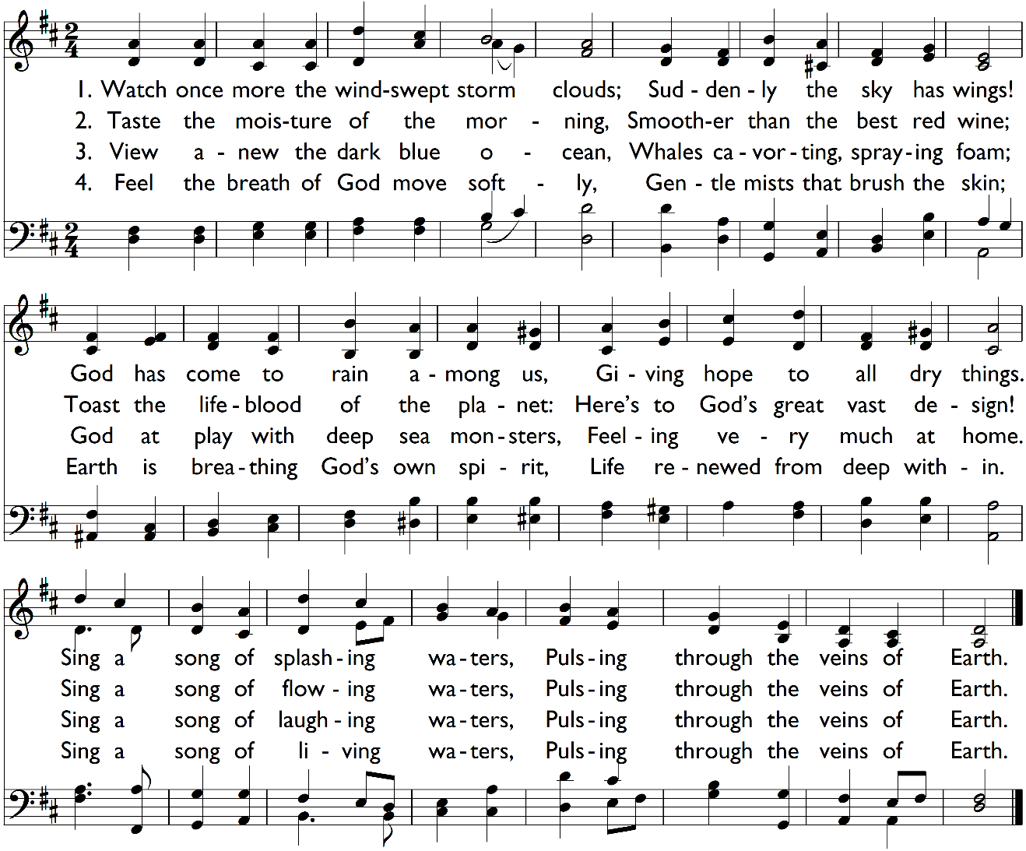
Song of the Waters

Music: Lauda Anima, John Goss, 1869; public domain • Words: Norman Habel, 2001; used by permission.

This Week at Salisbury UCC

Sunday, September 8
9:15am Pancake Breakfast
10:00am Worship Service & Church School
11:30am Ushers meeting
Monday, September 9
1pm Salisbury Duplicate Bridge
Tuesday, September 10
7pm Sinfonietta rehearsal
Wednesday, September 11
9am Staff Meeting
10am Music Committee Meeting
11am Worship at Noble Horizons
7:15pm Choir rehearsal
Thursday, September 12
4:30pm Women’s Bible Study
7pm HousaTonics
Friday, september 13
7:45am Men’s Bible Study
Sunday, September 15
10:00am Worship Service & Church School
11:30am Christian Action meeting (Meetinghouse)
11:30am Trustees meeting (Council Rm)

Please Recycle this Bulletin!

The Congregational Church of Salisbury
United Church of Christ
Whoever you are, wherever you are on life’s journey: you are welcome here.
30 Main Street | P.O. Box 392 | Salisbury, CT 06068 • 860-435-2442
info@salisburycongregationalchurch.org
www.salisburycongregationalchurch.org
Office Hours: 9am – 2pm, Monday-Friday

