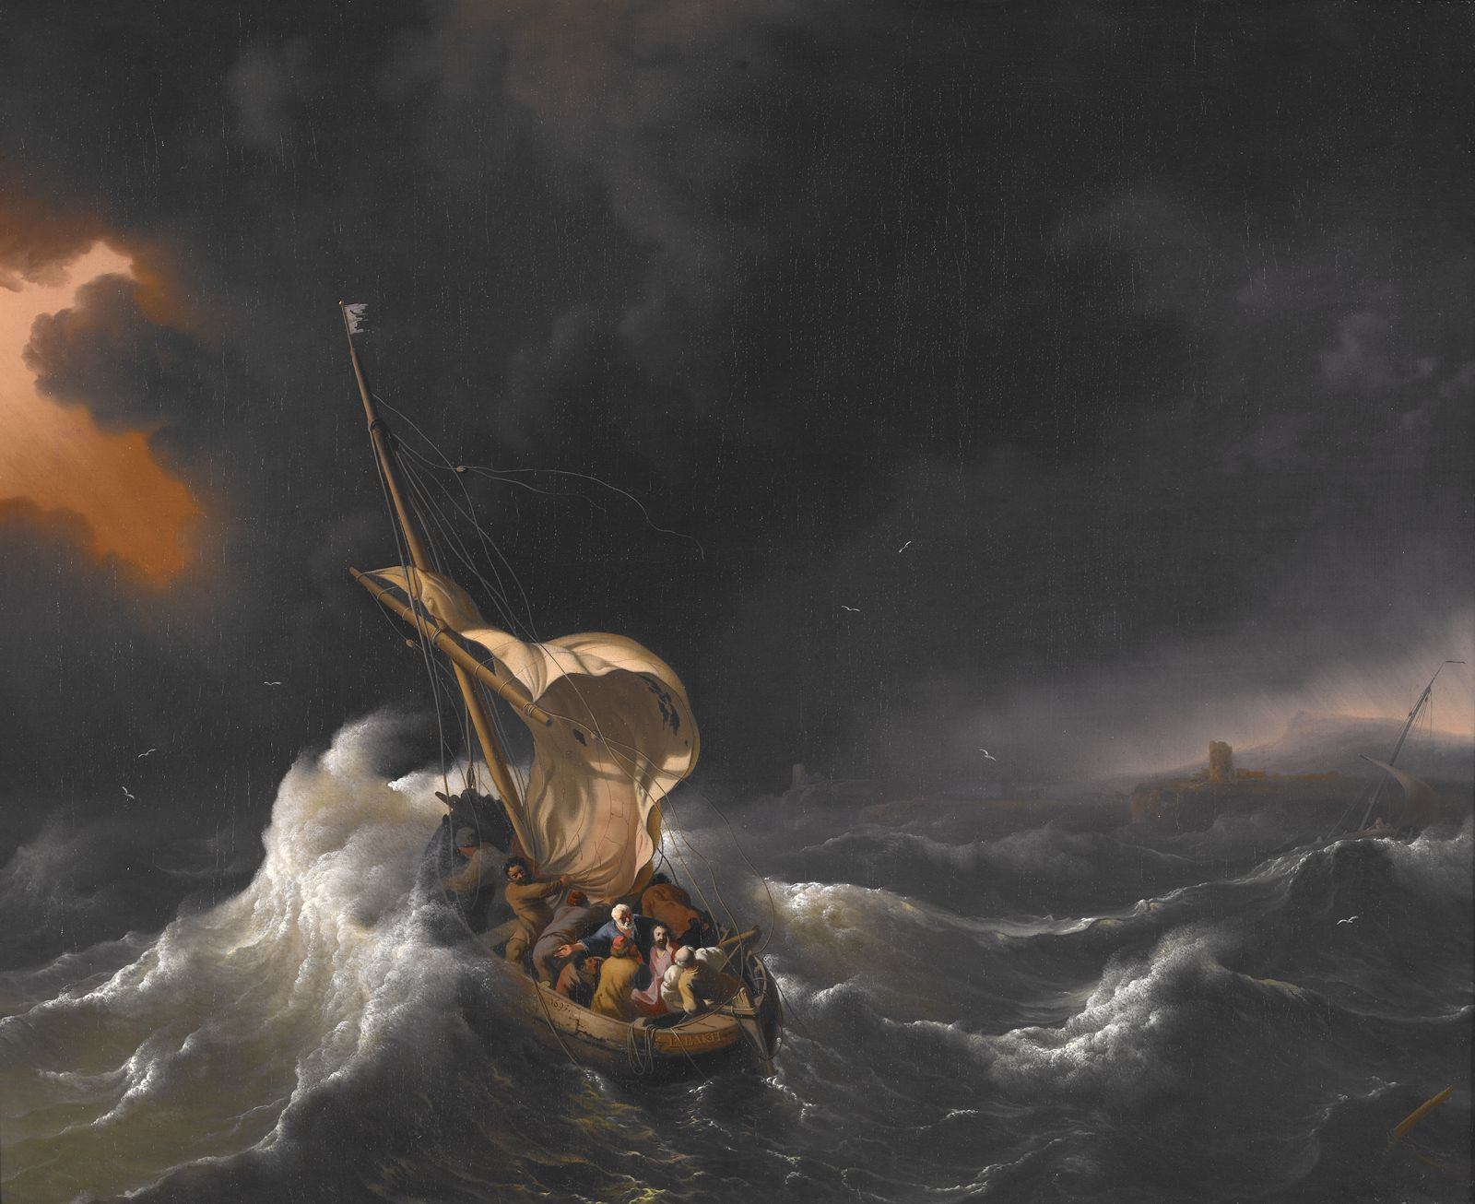
The Congregational
Church of Salisbury
United Church of Christ

Whoever you are; wherever you are on life’s journey: you are welcome here.

22 September 2019 • 10:00am
Fifteenth Sunday
Season of Creation • Storm Sunday
Welcome!
We worship this Sunday with the storm. We sing with the winds, the clouds, and the thunder. We feel the awesome events of nature. We experience the stillness before the storm, the frightening fury of the winds, and the destructive aftermath of the tornado. We experience God’s presence in all these things. We experience God’s presence in the storm.
Chiming of the Hour
Welcome
Prelude “St. Anthony Chorale” F.J. Haydn
Announcements | Joys and Concerns | Silent Prayer
Gathering
One: In the name of God, present in the thunder of the storm.
In the name of Christ, present in the stillness after the storm.
In the name of the Spirit, present in the winds of the storm.
All: Holy! Holy! Holy! Earth is filled with God’s presence.
Christ, as we come to into this sanctuary today,
we enter your presence even in the storm.
Holy! Holy! Holy! Earth is filled with your presence.
Introit #768 “Somos el cuerpo de Cristo”
Call to Worship
One: We invite the elements of the storm to worship with us:
All: the wild winds and the dark clouds,
the lightning flash and the thunder roll.
We invite the storm to join us in awe of the Creator:
the fierce gales and blinding rains,
the crashing waves and swaying trees.
Where is God in all of this? Where is God in the storm?
God created all things; God is buffeted by the storm.
Where is our God in the tornado?
As the crucified Christ, suffering with those who are battered;
As the risen Christ, offering new life out of loss.
Where is our God in the blizzard?
As the crucified Christ, abiding with the grieving;
As the risen Christ, providing comfort and hope.
Yes, where is our God in all of this?
God is working for good in all things. All praise to God!
Hymn (insert) “Stand By Me” Roeder
Remembering
One: Take a quiet moment now, to remember a time when you were surrounded by extreme weather that awed and frightened you, or when you witnessed others shaken by tempests. (Silent reflection) We remember fierce storms: times when we questioned God’s role in our world.
We remember asking, “Why? Where was our God in all of this?”
Confession
We remember and confess our doubts.
We have doubted God’s presence;
We have doubted God’s goodness;
We have doubted God’s love.
The congregation may rise, in body or in spirit
When hurricanes and blizzards have struck,
We have doubted God’s presence.
In the wake of human suffering,
We have doubted God’s goodness.
In the wake of the devastations of nature,
We have doubted God’s love.
We bring these doubts before you, God.
We confess our doubts. We seek a restoration of confidence in you.
As we name our uncertainties about God,
Christ, have mercy.
As we confess our doubts about the storms that shake our lives,
Teacher, have mercy.
As we discover God’s healing presence.
Christ, have mercy.
Absolution
Christ hears your confession, receives your doubts and uncertainties,
and assures you that even in the fiercest storm the healing power
of Christ is present, to comfort and offer new life.
Christ, assure us of your presence in all things;
Assure us of your goodness and love.
I speak for Christ: your God is not high in heaven,
playing wild games with nature.
Our God is deep within each storm.
Our God is the suffering God, revealed to us at Calvary,
and abiding with all who suffer in the aftermath of storms.
Our God is the God of resurrection and new life.
Shalom! Shalom! God’s compassion and forgiveness are ours,
every moment we take shelter in God’s presence.
Affirmation of Faith
One: Let us affirm our faith together.
North side: We believe that God creates all things,
renews all things, and celebrates all things.
South side: We believe Earth is a sanctuary, a sacred planet filled with God’s presence, a home for us to share with our kin.
North side: We believe that God became flesh and blood,
became part of Earth, a human being called Jesus Christ,
who lived and breathed and spoke among us,
suffered and died on a cross,
for all human beings and for all creation.
South side: We believe that the risen Jesus is the Christ at the core of creation, reconciling all things to God, renewing all creation and filling the universe.
North side: We believe the Spirit renews life in creation
groans in empathy with a suffering creation,
and waits with us for the rebirth of creation.
All: We believe that with Christ we will rise
and with Christ we will celebrate a new creation!
Gloria #584 “Glory, Glory, Glory”

We Proclaim the Gospel in Word
A Thought for Young Minds
The Lord’s Prayer (debts)
Hymn #8 “Eternal Father, Strong to Save” Melita
Children (PreK–8th grade) attending Church School may leave as we sing the hymn.
Responsive Psalter: Psalm 29
Ascribe to the Almighty, O heavenly beings,
Ascribe to the Almighty and to none other,
Ascribe to the One God splendor and strength.
Ascribe to the Holy One the wonder of God’s renown;
Bow down before the Most High,
who is Holiness and Splendor.
The voice of the Most High is over the waters;
The God of glory thunders,
The Almighty, over mighty waters.
The voice of the Holy One is power;
The voice of the Holy One is magnificence.
The voice of the Holy One breaks the cedars;
The Holy One shatters the tallest cedars.
And makes the mountain range skip like a calf,
And the northern region cavort like a young wild ox.
The voice of the Most High flashes forth flames of fire.
The voice of the Most High convulses the wilderness;
The Most High convulses the wilderness of the battle ground.
The voice of the Almighty causes the oaks to whirl,
And strips the forest bare, so that in God’s temple all say, “Glory!”
The One God sits enthroned over the flood;
The One God sits enthroned and reigns forever.
The Almighty pours out strength to the people!
The Almighty blesses the people with peace.
Gospel Reading: Luke 8:22-25
Sermon “Wisdom of the Storm” John A. Nelson

We Respond in Prayer and Faith
Pastoral Prayer | Silent Prayer
Offertory
One: Storms rage, lives roil with trouble, the creation groans — and yet our God keeps pouring out blessing and bounty, healing and hope, reconciliation and righteousness. So in tempest, as in calm, we return praise to God. As one way of giving thanks, we imitate God’s amazing generosity with our own, through our tithes and offerings.
All: With all creation, and with all our giving, we bless our Creator.
Receiving Our Offerings
Musical Offering “The Heavens are Telling the Glory of God” F.J. Haydn
Andrea Barbabos, soprano; Pastor John, tenor; Deryl Godshall, baritone
Creation Doxology Lasst uns Erfreuen
To you, O God all creatures sing,
And all creation, everything
sings your praises, alleluia!
Praise the Creator; Christ we praise!
And for the Spirit joy we raise!
Alleluia, alleluia, alleluia, alleluia, alleluia!
Unison Prayer of Dedication
Mighty Creator, all things belong to you: we are your caretakers. We pray that these gifts, which you gave that we might be of service, will now be a blessing to your world. We pray they may multiply, as we join with all creatures who revere you, the source of life and love. In Jesus’ name, Amen.
Hymn #463 “How Firm a Foundation” Foundation
Benediction and Sung Amen (Hymnal, #600)
Postlude “In Thee is Gladness” J.S. Bach

Welcome to Church!
Gathered in 1744, the Congregational Church of Salisbury is an Open and Affirming member of the United Church of Christ. It is also a welcoming home to people from a great variety of church backgrounds and life experiences. Your presence here today is a gift to us! We hope you will feel God’s Spirit here today through our worship and fellowship.
We seek to love God with all our hearts, souls, and minds and love our neighbors as ourselves. This Church is Open to all for participation, membership, leadership and employment regardless of race, ancestry, class, gender identity, physical and mental ability or sexual orientation. We Affirm each individual as a child of God, celebrating the total identity of each person.
As an Open and Affirming Congregation, we commit to work toward ending ignorance, fear, hatred, prejudice, and discrimination against any person.
Whoever you are, wherever you are on life’s journey,
you are welcome here!
If you are visiting us today, Welcome! Please sign our guest book and introduce yourself to our Pastor or to one of the Deacons. Fill out a welcome card in the pew to be put on our email list — and please join us in the Parish Hall for refreshments and fellowship following worship. Assistive Listening Devices are available. Please ask an usher for assistance!

Please set cell phones and pagers to silent mode
(unless you’re expecting a call from Jesus)
Today’s Worship Leaders
Ushers: Deborah Moore & Kathy Mera
Worship Leader: Karin Noyes
Deacon: Carol Magowan
Flowers have been placed in the sanctuary to the Glory of God.
Today’s service is adapted from materials sponsored by Norman Habel and the Justice and International Mission unit
within the Commission for Mission of the Uniting Church in Australia, Synod of Victoria and Tasmania. Used with permission. Cover art: Ludolf Backhuysen (1631-1708), “Christ in the Storm on the Sea of Galilee” (1695).

Our Ministry Team
Ministers: All Participants in the Life of the Congregation

Worship & Music
Music Minister: Dr. Jack Bowman
Bell Choir Director: Mary Davidson
Technical Minister: Lee Collins

Education & Youth
Christian Education Minister: Barbara Collins
Youth Minister: Jennifer Surdam

Holding the Parts Together!
Administrative Assistant: Kathleen Wiggins
Finance and Communications Assistant: Melissa Adam
Sexton: Cory Wiggins
Church Officers: Betsy Beck, moderator; Jennifer Weigel, treasurer; Jennifer Oberto, clerk

Pastor and Teacher: The Rev. Dr. John A. Nelson

Occasions for Service, Witness, and Prayer
When you walk in the CROP Hunger Walk, you are raising money to help fight hunger but you are also walking in solidarity with all of those people around the world who are walking for food, for water and for firewood each day. Only one week left to sign up to be a Walker or sponsor! We now have four Walkers participating from our congregation. To become a Walker or sponsor, please see Pastor John. The CROP Hunger Walk is truly about us all fighting hunger in many ways throughout the world!! Come walk with us!

In Our Prayers:
We gladly list joys and concerns, and typically print them for four weeks
after they are offered in worship. (Prayer requests may be renewed at any time.)

Continuing concerns:
Deryl Godshall, recovering from injury[thru 13 Oct] • those whose lives are devastated by Hurricane Dorian and other natural disasters[thru 25 Sep] • Jenn Oberto, recovering from surgery[thru 6 Oct] • survivors of mass shootings, and those working to combat the crisis of gun violence • Henry • Sally Dowling • Carole Fraher • Peter Kuhbach • Sherrell Andrews • Dale Sapp • Sean Clegg • Roberta Fay • J. Kevin Carroll • Evan Adsit • Marty Sorenson • Terry Roy & family • Petee Robinson • Dick Taber • Tom Splaine • Joe K. • Peter & Linda • Paula & Herman • Anne & Bill • Pauline • Sonya’s mother.
Friends and family now serving our country in the armed forces • All those serving or living in war or conflict zones around the world.

Family & Friends
who have passed away:
Jane Swanson • Ted Stanfield • Leonard Kaufman • Charles Bachman • Diane Franzen • Jimmy Bowman
We thank God for the gift of life, and pray God’s tender mercy on family and friends who are grieving.

If you would like a pastoral visit, please call the church office (860-435-2442) or email Pastor John (jnelson@salisburycongregationalchurch.org). Sometimes we don’t find out about an injury or illness or other need until long after — so please call!

Please Recycle this Bulletin!
The Congregational Church of Salisbury
United Church of Christ
Whoever you are, wherever you are on life’s journey: you are welcome here.
30 Main Street | P.O. Box 392 | Salisbury, CT 06068 • 860-435-2442
info@salisburycongregationalchurch.org
www.salisburycongregationalchurch.org
Office Hours: 9am – 2pm, Monday-Friday

