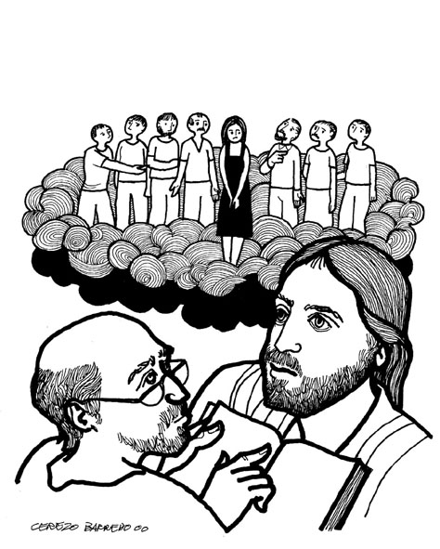
The Congregational
Church of Salisbury

United Church of Christ

10 November 2019 • 10:00am
Twenty-Second Sunday

We Gather in God’s Presence
Chiming of the Hour
Welcome
Prelude “Psalm XIX” Benedetto Marcello
Announcements | Joys and Concerns | Silent Prayer
Introit #413 “Come into God’s Presence”
Call to Worship
One: The God who is greater than we will ever understand,
All: is humbled to become one of us.
The God who is more loving than our hearts dare imagine,
gives us more grace than we ever realize.
The God who is wiser than we will ever know,
teaches us all we need to become God’s children.
All: Let us pour out our bold praise to God!
Hymn #234 “Come You Faithful, Raise the Strain” St. kevin
The congregation may rise, in body or in spirit
Call to Reconciliation
One: We often think that God is ‘out there’ somewhere, distant and uncaring. But God hears our hearts, God sees our struggles, God walks with us as we try to be faithful disciples. Let us come to the One who is as close as the very breath we take in this moment to confess the brokenness of our lives, as we pray together:
Unison Prayer of Confession
We are so easily confused by what the world tells us, Watching God, that we forget the stories of faith we heard as children. We are so fearful of tomorrow, we are not aware of your Spirit with us today. We are so busy wondering, ‘what if?’ or ‘suppose?’ we cannot hear the promises you whisper to us.
So once again, Gracious God, have mercy on us. You know our hearts so well — touch them with your grace. You see our deepest fears — heal them with your peace. You hear our secret longings— speak to them of your hope. This we pray in the name of Jesus Christ, our Teacher and Savior.
Silence is observed
Assurance of Pardon
One: The One who searches our broken hearts has found the way to mend them and make us new people. The good news is that everything God has done in Christ is for us, that we might be made whole.
All: With kindness, and justice, God makes us new people. We will sing our thanks through all eternity. Great is God, and greatly to be praised! Amen.
Gloria #582 “Glory to God, Whose Goodness Shines on Me” glory to god (Vasile)
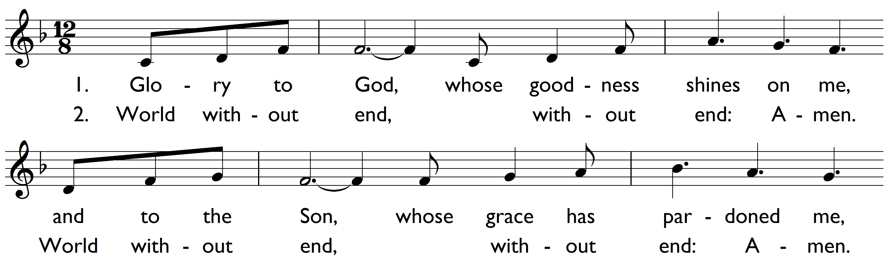

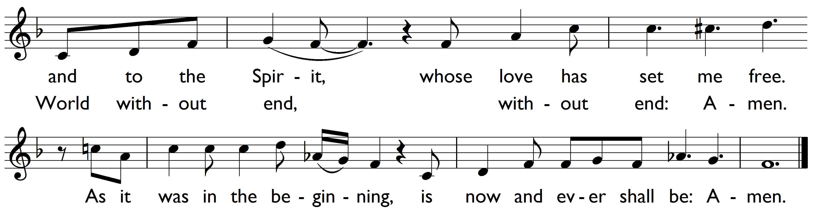

We Proclaim the Gospel in Word
A Thought for Young Minds
The Lord’s Prayer (debts)
Hymn #493 “Now There is No Male or Female” omne die (trier)
Children (PreK–5th grade) attending Church School
and the Youth Discussion Group may leave as we sing the hymn.
Responsive Psalter: Psalm 98
One: O sing a new song to God Most High,
Who has done marvelous things.
Many: The Holy One’s strong hand and saving arm
have delivered us from bondage.
The Almighty has made our deliverance known,
And has revealed this concern for the people
in the sight of the nations.
The Most High has always shown love and faithfulness to the people.
All the ends of the earth have seen the deliverance by our God.
Shout for joy to God Most High, all the earth;
Break forth into joyous song.
Make music to the Holy One with the lyre,
With the lyre and melodious song.
With trumpets and the sound of the horn
make a joyful noise before the Almighty, the One who reigns.
Let the sea roar, and all that fills it;
the world and those who live in it.
Let the rivers clap their hands;
Let the hills sing together for joy,
At the presence of the Holy One,
Who is coming to rule the earth.
The Almighty will rule the world with justice,
And the peoples with equity.
Scripture Reading Haggai 1:15b-2:9 Old Testament, p. 1074
Gospel Reading: Luke 20:27-38 New Testament, p.103
Sermon “Testing Limits” John A. Nelson

We Respond in Prayer and Faith
Pastoral Prayer | Silent Prayer
Offertory
One: In every which way, Jesus taught this: there’s no place we can go beyond the reach of God, the wonder of God, the mercy of God, the generosity of God! In gratitude for a God so extravagant with grace, we declare our praise by our giving!
All: Let us gather our gifts with grateful praise,
and offer them to God’s purposes.
Receiving Our Offerings
Musical Offering “O Lord, Almighty” Benedetto Marcello
Doxology Old 100th
Praise God from whom all blessings flow;
praise Christ, all people here below;
praise Holy Spirit ever more;
One God of grace, whom we adore! Amen.
Unison Prayer of Dedication
God, all that we hold and have belongs to you; we are your caretakers. In this moment of giving we pray that your grace will break through our fears and our certainties so that we may simply give, with the generosity taught by you, with the grace that comes from you. We pray your Spirit will bless these gifts, that they may carry your compassion to neighbors near and far. We ask in Jesus' name: Amen.
Hymn #238 “Thine is the Glory” judas maccabeus
Benediction #238 “Refrain: Thine is the Glory” Sung by all
Postlude “Psalm XX” Benedetto Marcello

Welcome to Church!
Gathered in 1744, the Congregational Church of Salisbury is an Open and Affirming member of the United Church of Christ. It is also a welcoming home to people from a great variety of church backgrounds and life experiences. Your presence here today is a gift to us! We hope you will feel God’s Spirit here today through our worship and fellowship.
We seek to love God with all our hearts, souls, and minds and love our neighbors as ourselves. This Church is Open to all for participation, membership, leadership and employment regardless of race, ancestry, class, gender identity, physical and mental ability or sexual orientation. We Affirm each individual as a child of God, celebrating the total identity of each person.
As an Open and Affirming Congregation, we commit to work toward ending ignorance, fear, hatred, prejudice, and discrimination against any person.
Whoever you are, wherever you are on life’s journey,
you are welcome here!
If you are visiting us today, Welcome! Please sign our guest book and introduce yourself to our Pastor or to one of the Deacons. Fill out a welcome card in the pew to be put on our email list — and please join us in the Parish Hall for refreshments and fellowship following worship. Assistive Listening Devices are available. Please ask an usher for assistance!

Please set cell phones and pagers to silent mode
(unless you’re expecting a call from Jesus)

Today’s Worship Leaders
Ushers: Sarah Morrison & Sal Accardo
Liturgist: John Estabrook
Deacon: Lorna Edmundson
Coffee Hour Servers: Youth Group
Flowers have been placed in the sanctuary to the Glory of God.
Portions of today’s service are adapted and reprinted from Lectionary Liturgies by the Rev. Thom Shuman © 2019 (lectionaryliturgies.blogspot.com). Used with permission. Psalm 98 adapted from The Psalms in Worship, Mary Susan Gast, © 2002; used by permission. Cover art by Fr. Maximino Cerezo Barredo (1932–).

Our Ministry Team
Ministers: All Participants in the Life of the Congregation

Worship & Music
Music Minister: Dr. Jack Bowman
Bell Choir Director: Mary Davidson
Technical Minister: Lee Collins

Education & Youth
Christian Education Minister: Barbara Collins
Youth Minister: Jennifer Surdam

Holding the Parts Together!
Administrative Assistant: Kathleen Wiggins
Finance and Communications Assistant: Melissa Adam
Sexton: Cory Wiggins
Church Officers: Betsy Beck, moderator; Jennifer Weigel, treasurer; Jennifer Oberto, clerk

Pastor and Teacher: The Rev. Dr. John A. Nelson

Occasions for Service, Witness, and Prayer

In Our Prayers:
We gladly list joys and concerns, and typically print them for four weeks
after they are offered in worship. (Prayer requests may be renewed at any time.)

Continuing concerns:
Baby Bennett and family[thru 1 Dec] • Audrey Eriksson[thru 1 Dec] • Sally and Robert Hammett[thru 24 Nov] • Bob True[thru 24 Nov] • Dick Good[thru 24 Nov] • Sal Accardo[thru 24 Nov] • Naomi Feldman[thru 24 Nov] • Deryl Godshall, recovering from injury • those whose lives are devastated by hurricanes and other natural disasters • survivors of mass shootings, and those working to combat the crisis of gun violence • Peter Kuhbach • Sherrell Andrews • Dick Taber
Friends and family now serving our country in the armed forces • All those serving or living in war or conflict zones around the world.

Family & Friends
who have passed away:
Ted Stanfield • Leonard Kaufman • Diane Franson • Tony Scoville[thru 17 Nov]
We thank God for the gift of life, and pray God’s tender mercy on family and friends who are grieving.

If you would like a pastoral visit, please call the church office (860-435-2442) or email Pastor John (jnelson@salisburyucc.org). Sometimes we don’t find out about an injury or illness or other need until long after — so please call!
Report from the Christmas Giving Project: The Board of Christian Action has chosen three charities to receive gifts through the Christmas Giving Tree Project this year: Simply Smiles, Astor House, and Women’s Support Services. In addition, we will donate to support our sister church, Nourish Bridgeport through a donation to fund the annual “Feel the Warmth” Dinner. Anyone interested in assisting in this endeavor should contact Joanne Hayhurst or Margie Vail,ß or attend the initial meeting on November 18th at 1pm in the Council Room (2nd floor of the Church House).

This Week at Salisbury UCC

Sunday, 10 November
10am Worship, Church School, and Youth Discussion Group
monday, 11 november
1pm Salisbury Duplicate Bridge
Tuesday, 12 november
5:15pm Bell Choir Rehearsal
Wednesday, 13 november
9am Staff Meeting
11am Worship at Noble Horizons
7:15pm Choir Rehearsal
Thursday, 14 november
4:30pm Women’s Bible Study
7pm HousaTonics
Friday, 15 november
7:45am Men’s Bible Study

Please Recycle this Bulletin!
The Congregational Church of Salisbury
United Church of Christ
Whoever you are, wherever you are on life’s journey: you are welcome here.
30 Main Street | P.O. Box 392 | Salisbury, CT 06068 • 860-435-2442
info@salisburycongregationalchurch.org
www.salisburycongregationalchurch.org
Office Hours: 9am – 2pm, Monday-Friday

